**ABSTRACT FACTORY**

1. **Example related to Abtract factory.**

- Abstract factory pattern in useful when the client needs to create objects which are somehow related. If we need to create the family of related or dependent objects, then we can use Abstract Factory Pattern.

- This pattern is useful when the client doesn’t know exactly what type to create.

* Example relates to ABTRACT FACTORY:

- A store sells smartphone made by X company.

Here we don’t know exactly which type of objects be created, and we also look for smart phone manufactured by X company.

**4. Abtract Factory**

- Abstract Factory design pattern is a part of **Creational pattern.** Abstract Factory pattern is almost similar to Factory Pattern and is considered to have a extra layer of abstraction over factory pattern.

- Abstract factory pattern provides a **framework**that allows to create objects that follows a pattern. So at runtime, abstract factory is coupled with any desired factory which can create objects of desired type.

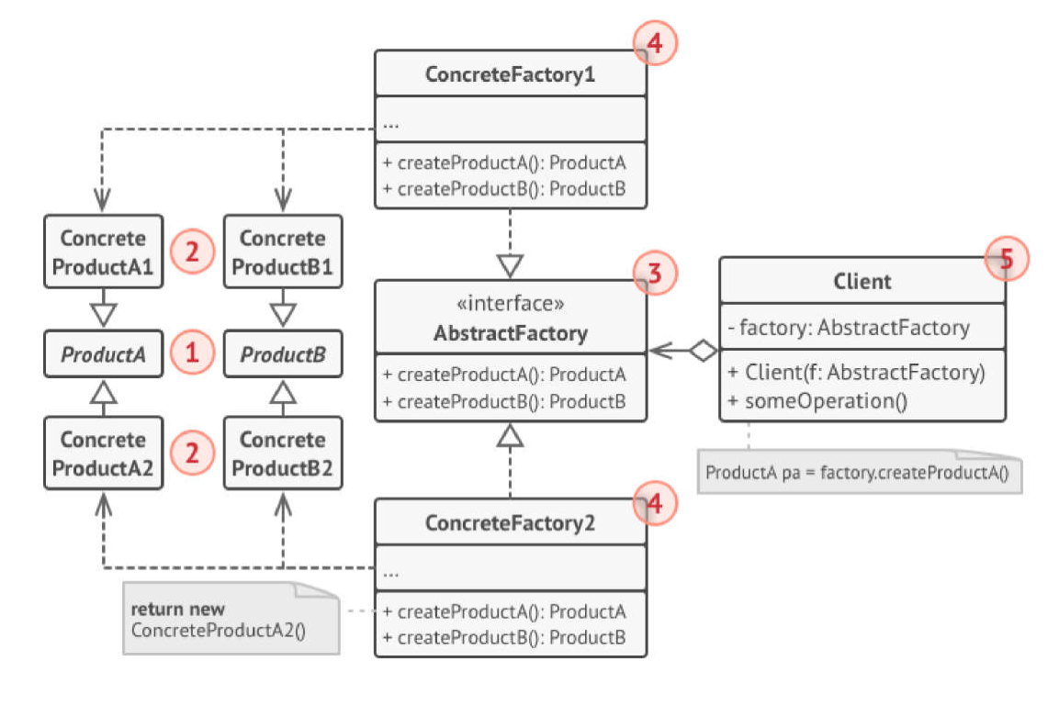Structure of ABTRACT FACTORY:

**->** Therein:

a. **AbtractFactory:** declares an interface for operation that create abtract products.

b. **ConcreteFactory:** implements the operations to create concrete product.

c. **AbtractProduct:** declares an interface for a type of product object.

d. **ConcreteProduct:** Installation of specific objects, installation of methods is specified in AbstractProduct.

e. **Client:** objects that use AbtractFactory and AbtractProduct classes.

**7. Pros and cons of Abstract Factory**

***\* Pros:***

- The Abstract Factory Pattern helps ensure that the products you receive from a factory are compatible

- Abstract Factory Pattern helps limit the dependency between creator and concrete products.

- Abstract Factory Pattern helps to gather the code to create products into one place in the program, thus helping to track and manipulate.

- With Abstract Factory Pattern, we can freely add many new products to the program without changing the existing code base.

***\*Cons:***

-The code can become more and more complex due to the need to use multiple classes to install this pattern.